Physical Science
Chapter 1
NAME

MOVING THE DECIMAL POINT
Because the metric system is based on decimals, you can change one metric measurement to another that is larger or smaller simply by moving the decimal point either to the left or right.
For example, to change grams to milligrams, move the decimal point three spaces to the right. This is the same as multiplying by 1000 (1 gram = 1000 milligrams).
0.536 = 536 mg
Move the decimal point to the left to designate larger units.
536 mg = 0.536 g

larger units <<<<< |  | < MOVING THE DECIMAL POINT> |  |  | >> >> smaller units
kilo- | hecto- | deka- | basic unit | deci-* | centi-* | milli-*
0.001 km = | 0.01 hm = | 0.1 dam = | 1 .0 meter = | 10. dm | =100. cm = | 1000. mm
0.001 kg = 0.001 kL = | 0.01 hg =  0.01 hL = | 0.1 dag =  0.1 daL = | 1 .0 gram = 1.0 liter = | 10. dg 10. dL | = 100. cg = 100. cL = | 1000. mg 1000 ml
* Ordinarily, you wouldn't use a decimal point after a whole number.

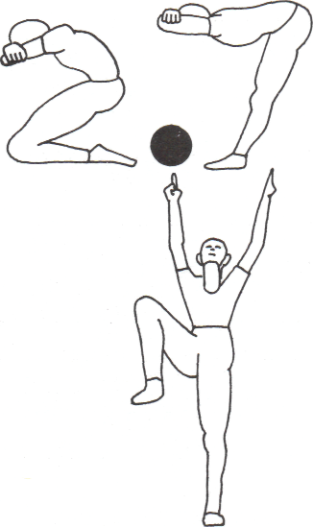
(1) Change centimeters to meters:
37.5 cm ___________ m
(2) Change liters to milliliters:
0.017 L = mL
(3) A more convenient way to express 0.042 kiloliters:
______________________

(4) A more convenient way to express 41,672mm:
_________________________
(5) A more convenient way to express 0.650 g:
________________________

(6) Change kilometers to meters:
0.71 km = m
(7) Change milligrams to kilograms:
3600 mg = kg
(8) 500 milligrams (mg) of Vitamin C is the same as
g
kg
(9) Which is greater?
1 g or 230 mg
________________
(10) How many milligrams is 1 gram?__________

