Student of the Month
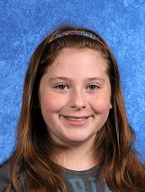
Elizabeth – April Good Citizen
Mr. Long’s 5th Grade Class
Congratulations to Elizabeth our April Good Citizen. Elizabeth was chosen because she is hard working, has great attendance and is polite and kind to the students and staff of Hillside Elementary. Her favorite subject at school is math. Elizabeth likes to read books about animals and poetry. In her spare time she enjoys cheerleading, Girls on the Run and playing with her sister Iva. She also has a dog (Copper) and two cats named Fatso and Carter. Her favorite food is pizza. Elizabeth’s favorite vacation was to Upper Peninsula. She also likes the color white and loves to listen to country music. Awesome job Elizabeth, keep up the great work!

